

Project Report
Introduction to Data Science
Semester – 2
“Global Trade Analysis: 34 Years of Export-Import Data (1988–2021)”
By
Prem Panchal
Reg no: 2411021240011

Department of Computer Application
Alliance University Chandapura — Anekal Main Road,
Anekal Bengaluru — 562 106
April 2025
Project Overview
This project focuses on analysing a dataset covering 34 years of global trade. The data includes export and import values for multiple countries from 1988 to 2021. By cleaning, transforming, visualizing, and modelling this dataset, we aim to uncover patterns, trends, and insights about the global economy and trade relationships.
The study also uses machine learning techniques like Linear Regression to predict imports based on export values, providing practical forecasting tools for policy makers and economists.

Project Goals
- To understand long-term trends in global exports and imports
- To identify top trading countries and their trade evolution
- To compute and analyse trade balances
- To visualize patterns using graphs, heatmaps, and plots
- To apply regression modelling for prediction of trade values
- To create a well-structured analytical report for academic and industry relevance

Challenges Faced
- Data Cleaning: Inconsistent column names, missing values, and formatting issues
- Large Dataset Size: Aggregating 34 years of data across many countries required careful optimization
- Visualization Complexity: Representing trends clearly without cluttered visuals
- Model Accuracy: Achieving a good R² value while avoiding overfitting
- Report Design: Balancing technical depth with visual clarity for a ~20-page PDF

Tools and Libraries Used
- Pandas – Data manipulation and transformation
- Matplotlib & Seaborn – Graphs and visualizations
- Scikit-learn – Linear regression modelling and evaluation
- Jupyter Notebook – Interactive development
- MS Word / LaTeX / PDF Export – Final report generation

import pandas as pd
df=pd.read_csv(r"C:\Users\Prem Panchal\Downloads\34_years_world_export_import_dataset.csv")
df
Partner Name Year Export (US$ Thousand) \
0 Aruba 1988 3.498100e+03
1 Afghanistan 1988 2.130304e+05
2 Angola 1988 3.755279e+05
3 Anguila 1988 3.669800e+02
4 Albania 1988 3.010356e+04
... ... ... ...
8091 Latin America & Caribbean 2021 1.330557e+09
8092 Middle East & North Africa 2021 1.196712e+09
8093 North America 2021 3.823319e+09
8094 South Asia 2021 6.991380e+08
8095 Sub-Saharan Africa 2021 4.951000e+08
Import (US$ Thousand) Export Product Share (%) \
0 3.284900e+02 100.0
1 5.445952e+04 100.0
2 3.707028e+05 100.0
3 4.000000e+00 100.0
4 4.770930e+04 100.0
... ... ...
8091 1.310305e+09 100.0
8092 1.088471e+09 100.0
8093 2.219849e+09 100.0
8094 4.723832e+08 100.0
8095 4.350468e+08 100.0
Import Product Share (%) Revealed comparative advantage \
0 100 NaN
1 100 NaN
2 100 NaN
3 100 NaN
4 100 NaN
... ... ...
8091 100 NaN
8092 100 NaN
8093 100 NaN
8094 100 NaN
8095 100 NaN
World Growth (%) Country Growth (%) AHS Simple Average (%) ... \
0 NaN NaN 2.80 ...
1 NaN NaN 0.88 ...
2 NaN NaN 2.02 ...
3 NaN NaN 3.71 ...
4 NaN NaN 1.84 ...
... ... ... ... ...
8091 NaN NaN 3.84 ...
8092 NaN NaN 4.63 ...
8093 NaN NaN 6.45 ...
8094 NaN NaN 5.09 ...
8095 NaN NaN 3.22 ...
MFN Total Tariff Lines MFN Dutiable Tariff Lines Share (%) \
0 1152.0 63.54
1 4142.0 69.41
2 5438.0 76.00
3 322.0 66.15
4 5684.0 66.87
... ... ...
8091 1509731.0 67.97
8092 1507304.0 67.98
8093 1533357.0 67.86
8094 1508290.0 67.94
8095 1513840.0 67.92
MFN Duty Free Tariff Lines Share (%) \
0 22.74
1 15.64
2 16.27
3 22.05
4 19.19
... ...
8091 25.91
8092 25.91
8093 26.04
8094 26.02
8095 25.93
MFN Specific Tariff Lines Share (%) MFN AVE Tariff Lines Share (%) \
0 70.32 31.61
1 72.45 40.51
2 41.55 24.80
3 78.79 36.36
4 57.93 48.52
... ... ...
8091 0.39 5.08
8092 0.46 5.92
8093 0.59 7.58
8094 0.68 8.71
8095 0.70 8.99
MFN MaxRate (%) MFN MinRate (%) \
0 352.69 0.0
1 2029.66 0.0
2 451.15 0.0
3 100.00 0.0
4 3000.00 0.0
... ... ...
8091 3000.00 0.0
8092 3000.00 0.0
8093 3000.00 0.0
8094 3000.00 0.0
8095 3000.00 0.0
MFN SpecificDuty Imports (US$ Thousand) \
0 2.186000e+03
1 7.843691e+04
2 7.277420e+05
3 9.400000e+01
4 3.790409e+04
... ...
8091 4.193397e+08
8092 5.809079e+08
8093 6.433132e+08
8094 8.497724e+07
8095 2.234618e+08
MFN Dutiable Imports (US$ Thousand) \
0 3.128020e+03
1 9.419150e+04
2 9.214815e+05
3 5.830000e+02
4 1.011959e+05
... ...
8091 1.346740e+09
8092 1.117309e+09
8093 2.055953e+09
8094 5.123190e+08
8095 4.915992e+08
MFN Duty Free Imports (US$ Thousand)
0 0.00
1 0.00
2 0.00
3 0.00
4 0.00
... ...
8091 1632.05
8092 0.00
8093 23691.96
8094 0.05
8095 2.83
[8096 rows x 33 columns]
#Understanding the data
df.head()
Partner Name Year Export (US$ Thousand) Import (US$ Thousand) \
0 Aruba 1988 3498.10 328.49
1 Afghanistan 1988 213030.40 54459.52
2 Angola 1988 375527.89 370702.76
3 Anguila 1988 366.98 4.00
4 Albania 1988 30103.56 47709.30
Export Product Share (%) Import Product Share (%) \
0 100.0 100
1 100.0 100
2 100.0 100
3 100.0 100
4 100.0 100
Revealed comparative advantage World Growth (%) Country Growth (%) \
0 NaN NaN NaN
1 NaN NaN NaN
2 NaN NaN NaN
3 NaN NaN NaN
4 NaN NaN NaN
AHS Simple Average (%) ... MFN Total Tariff Lines \
0 2.80 ... 1152.0
1 0.88 ... 4142.0
2 2.02 ... 5438.0
3 3.71 ... 322.0
4 1.84 ... 5684.0
MFN Dutiable Tariff Lines Share (%) MFN Duty Free Tariff Lines Share (%) \
0 63.54 22.74
1 69.41 15.64
2 76.00 16.27
3 66.15 22.05
4 66.87 19.19
MFN Specific Tariff Lines Share (%) MFN AVE Tariff Lines Share (%) \
0 70.32 31.61
1 72.45 40.51
2 41.55 24.80
3 78.79 36.36
4 57.93 48.52
MFN MaxRate (%) MFN MinRate (%) MFN SpecificDuty Imports (US$ Thousand) \
0 352.69 0.0 2186.00
1 2029.66 0.0 78436.91
2 451.15 0.0 727741.99
3 100.00 0.0 94.00
4 3000.00 0.0 37904.09
MFN Dutiable Imports (US$ Thousand) MFN Duty Free Imports (US$ Thousand)
0 3128.02 0.0
1 94191.50 0.0
2 921481.52 0.0
3 583.00 0.0
4 101195.95 0.0
[5 rows x 33 columns]
df.tail()
Partner Name Year Export (US$ Thousand) \
8091 Latin America & Caribbean 2021 1.330557e+09
8092 Middle East & North Africa 2021 1.196712e+09
8093 North America 2021 3.823319e+09
8094 South Asia 2021 6.991380e+08
8095 Sub-Saharan Africa 2021 4.951000e+08
Import (US$ Thousand) Export Product Share (%) \
8091 1.310305e+09 100.0
8092 1.088471e+09 100.0
8093 2.219849e+09 100.0
8094 4.723832e+08 100.0
8095 4.350468e+08 100.0
Import Product Share (%) Revealed comparative advantage \
8091 100 NaN
8092 100 NaN
8093 100 NaN
8094 100 NaN
8095 100 NaN
World Growth (%) Country Growth (%) AHS Simple Average (%) ... \
8091 NaN NaN 3.84 ...
8092 NaN NaN 4.63 ...
8093 NaN NaN 6.45 ...
8094 NaN NaN 5.09 ...
8095 NaN NaN 3.22 ...
MFN Total Tariff Lines MFN Dutiable Tariff Lines Share (%) \
8091 1509731.0 67.97
8092 1507304.0 67.98
8093 1533357.0 67.86
8094 1508290.0 67.94
8095 1513840.0 67.92
MFN Duty Free Tariff Lines Share (%) \
8091 25.91
8092 25.91
8093 26.04
8094 26.02
8095 25.93
MFN Specific Tariff Lines Share (%) MFN AVE Tariff Lines Share (%) \
8091 0.39 5.08
8092 0.46 5.92
8093 0.59 7.58
8094 0.68 8.71
8095 0.70 8.99
MFN MaxRate (%) MFN MinRate (%) \
8091 3000.0 0.0
8092 3000.0 0.0
8093 3000.0 0.0
8094 3000.0 0.0
8095 3000.0 0.0
MFN SpecificDuty Imports (US$ Thousand) \
8091 4.193397e+08
8092 5.809079e+08
8093 6.433132e+08
8094 8.497724e+07
8095 2.234618e+08
MFN Dutiable Imports (US$ Thousand) \
8091 1.346740e+09
8092 1.117309e+09
8093 2.055953e+09
8094 5.123190e+08
8095 4.915992e+08
MFN Duty Free Imports (US$ Thousand)
8091 1632.05
8092 0.00
8093 23691.96
8094 0.05
8095 2.83
[5 rows x 33 columns]
df.describe()
Year Export (US$ Thousand) Import (US$ Thousand) \
count 8096.000000 8.096000e+03 8.096000e+03
mean 2004.908226 1.421192e+08 1.305216e+08
std 9.707831 9.928417e+08 9.073802e+08
min 1988.000000 0.000000e+00 3.000000e-02
25% 1997.000000 4.274264e+05 1.601335e+05
50% 2005.000000 3.719683e+06 2.053967e+06
75% 2013.000000 2.585514e+07 2.102937e+07
max 2021.000000 2.422743e+10 2.193121e+10
Export Product Share (%) Import Product Share (%) \
count 8076.0 8096.0
mean 100.0 100.0
std 0.0 0.0
min 100.0 100.0
25% 100.0 100.0
50% 100.0 100.0
75% 100.0 100.0
max 100.0 100.0
Revealed comparative advantage World Growth (%) Country Growth (%) \
count 4712.0 4410.000000 4410.000000
mean 1.0 3.986016 3.986016
std 0.0 10.004221 10.004221
min 1.0 -62.280000 -62.280000
25% 1.0 -1.437500 -1.437500
50% 1.0 3.830000 3.830000
75% 1.0 9.407500 9.407500
max 1.0 174.000000 174.000000
AHS Simple Average (%) AHS Weighted Average (%) ... \
count 8080.000000 8080.000000 ...
mean 6.656053 6.082833 ...
std 3.837668 6.765269 ...
min 0.000000 0.000000 ...
25% 4.030000 2.100000 ...
50% 6.120000 4.700000 ...
75% 8.480000 8.050000 ...
max 46.980000 197.760000 ...
MFN Total Tariff Lines MFN Dutiable Tariff Lines Share (%) \
count 8.081000e+03 8081.000000
mean 4.291884e+05 72.722564
std 4.337735e+05 5.245883
min 1.700000e+01 37.110000
25% 6.481600e+04 69.400000
50% 2.669150e+05 71.340000
75% 7.071260e+05 75.260000
max 1.538248e+06 98.210000
MFN Duty Free Tariff Lines Share (%) \
count 8081.000000
mean 20.893574
std 4.554328
min 1.790000
25% 18.320000
50% 22.030000
75% 24.100000
max 62.890000
MFN Specific Tariff Lines Share (%) MFN AVE Tariff Lines Share (%) \
count 8080.000000 8080.000000
mean 52.018722 133.145250
std 84.848859 161.189034
min 0.000000 0.000000
25% 10.617500 33.375000
50% 28.180000 88.050000
75% 55.807500 176.242500
max 1800.000000 3860.000000
MFN MaxRate (%) MFN MinRate (%) \
count 8081.000000 8081.0
mean 2710.981771 0.0
std 840.575331 0.0
min 25.000000 0.0
25% 3000.000000 0.0
50% 3000.000000 0.0
75% 3000.000000 0.0
max 5000.000000 0.0
MFN SpecificDuty Imports (US$ Thousand) \
count 8.081000e+03
mean 5.454060e+07
std 4.137543e+08
min 0.000000e+00
25% 4.682219e+04
50% 9.012839e+05
75% 8.704754e+06
max 1.649501e+10
MFN Dutiable Imports (US$ Thousand) \
count 8.081000e+03
mean 1.097283e+08
std 7.691260e+08
min 9.400000e-01
25% 1.785371e+05
50% 2.048332e+06
75% 1.717688e+07
max 1.854956e+10
MFN Duty Free Imports (US$ Thousand)
count 8.081000e+03
mean 1.058794e+05
std 4.178933e+06
min 0.000000e+00
25% 0.000000e+00
50% 0.000000e+00
75% 0.000000e+00
max 3.495531e+08
[8 rows x 32 columns]
df.info()
<class 'pandas.core.frame.DataFrame'>
RangeIndex: 8096 entries, 0 to 8095
Data columns (total 33 columns):
# Column Non-Null Count Dtype
--- ------ -------------- -----
0 Partner Name 8096 non-null object
1 Year 8096 non-null int64
2 Export (US$ Thousand) 8096 non-null float64
3 Import (US$ Thousand) 8096 non-null float64
4 Export Product Share (%) 8076 non-null float64
5 Import Product Share (%) 8096 non-null int64
6 Revealed comparative advantage 4712 non-null float64
7 World Growth (%) 4410 non-null float64
8 Country Growth (%) 4410 non-null float64
9 AHS Simple Average (%) 8080 non-null float64
10 AHS Weighted Average (%) 8080 non-null float64
11 AHS Total Tariff Lines 8080 non-null float64
12 AHS Dutiable Tariff Lines Share (%) 8080 non-null float64
13 AHS Duty Free Tariff Lines Share (%) 8080 non-null float64
14 AHS Specific Tariff Lines Share (%) 8080 non-null float64
15 AHS AVE Tariff Lines Share (%) 8080 non-null float64
16 AHS MaxRate (%) 8080 non-null float64
17 AHS MinRate (%) 8080 non-null float64
18 AHS SpecificDuty Imports (US$ Thousand) 8081 non-null float64
19 AHS Dutiable Imports (US$ Thousand) 8081 non-null float64
20 AHS Duty Free Imports (US$ Thousand) 8081 non-null float64
21 MFN Simple Average (%) 8081 non-null float64
22 MFN Weighted Average (%) 8081 non-null float64
23 MFN Total Tariff Lines 8081 non-null float64
24 MFN Dutiable Tariff Lines Share (%) 8081 non-null float64
25 MFN Duty Free Tariff Lines Share (%) 8081 non-null float64
26 MFN Specific Tariff Lines Share (%) 8080 non-null float64
27 MFN AVE Tariff Lines Share (%) 8080 non-null float64
28 MFN MaxRate (%) 8081 non-null float64
29 MFN MinRate (%) 8081 non-null float64
30 MFN SpecificDuty Imports (US$ Thousand) 8081 non-null float64
31 MFN Dutiable Imports (US$ Thousand) 8081 non-null float64
32 MFN Duty Free Imports (US$ Thousand) 8081 non-null float64
dtypes: float64(30), int64(2), object(1)
memory usage: 2.0+ MB
print(df.shape)
(4410, 33)
import matplotlib.pyplot as plt
import seaborn as sns
import numpy as np
# Clean column names
df.columns = df.columns.str.strip()
# Create new features
df['Trade Balance'] = df['Export (US$ Thousand)'] - df['Import (US$ Thousand)']
df['Total Trade'] = df['Export (US$ Thousand)'] + df['Import (US$ Thousand)']
# Plot 1: Export and Import trends over time (world total)
yearly_data = df.groupby('Year')[['Export (US$ Thousand)', 'Import (US$ Thousand)']].sum().reset_index()
plt.figure(figsize=(12, 6))
sns.lineplot(data=yearly_data, x='Year', y='Export (US$ Thousand)', label='Export')
sns.lineplot(data=yearly_data, x='Year', y='Import (US$ Thousand)', label='Import')
plt.title('Global Export vs Import Over the Years')
plt.ylabel('US$ Thousand')
plt.grid(True)
plt.legend()
plt.tight_layout()
plt.show()
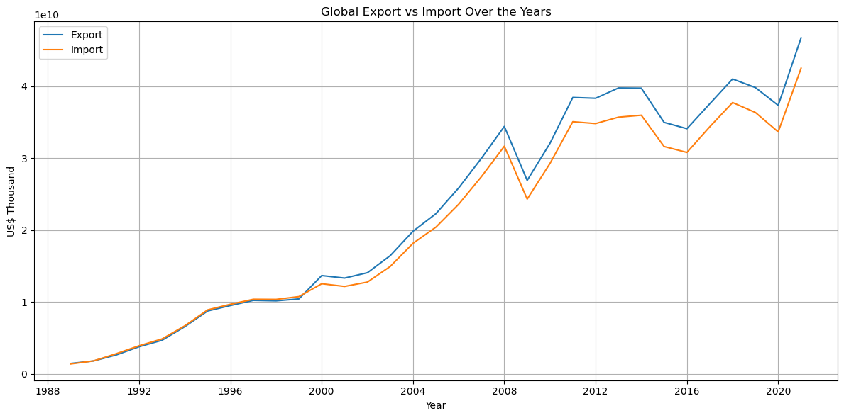
# Top 10 countries by total export and import over all years
top_exporters = df.groupby('Partner Name')['Export (US$ Thousand)'].sum().sort_values(ascending=False).head(10)
top_importers = df.groupby('Partner Name')['Import (US$ Thousand)'].sum().sort_values(ascending=False).head(10)
# Plot 2: Top 10 Exporting Countries
plt.figure(figsize=(12, 6))
sns.barplot(x=top_exporters.values, y=top_exporters.index, palette='viridis')
plt.title('Top 10 Exporting Countries (1988–2021)')
plt.xlabel('Total Export (US$ Thousand)')
plt.ylabel('Country')
plt.tight_layout()
plt.show()
# Plot 3: Top 10 Importing Countries
plt.figure(figsize=(12, 6))
sns.barplot(x=top_importers.values, y=top_importers.index, palette='magma')
plt.title('Top 10 Importing Countries (1988–2021)')
plt.xlabel('Total Import (US$ Thousand)')
plt.ylabel('Country')
plt.tight_layout()
plt.show()
C:\Users\Prem Panchal\AppData\Local\Temp\ipykernel_6580\3041476904.py:7: FutureWarning:
Passing `palette` without assigning `hue` is deprecated and will be removed in v0.14.0. Assign the `y` variable to `hue` and set `legend=False` for the same effect.
sns.barplot(x=top_exporters.values, y=top_exporters.index, palette='viridis')
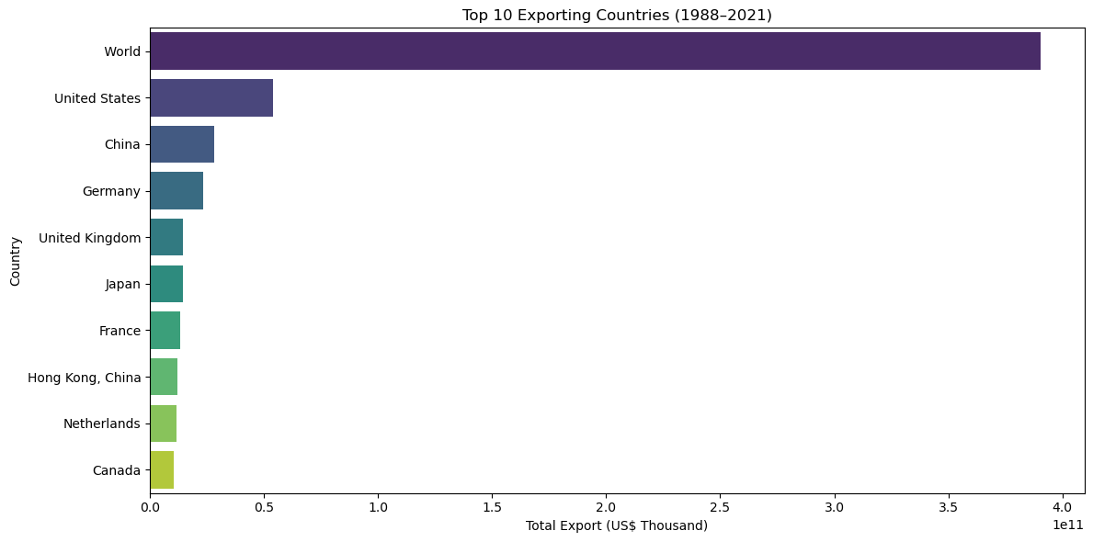
C:\Users\Prem Panchal\AppData\Local\Temp\ipykernel_6580\3041476904.py:16: FutureWarning:
Passing `palette` without assigning `hue` is deprecated and will be removed in v0.14.0. Assign the `y` variable to `hue` and set `legend=False` for the same effect.
sns.barplot(x=top_importers.values, y=top_importers.index, palette='magma')
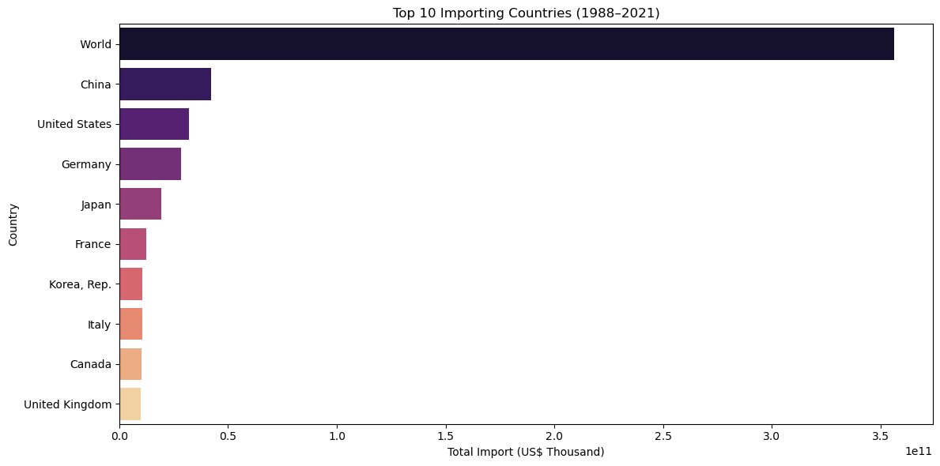
import pandas as pd
from sklearn.model_selection import train_test_split
from sklearn.linear_model import LinearRegression
from sklearn.metrics import mean_squared_error, r2_score
import matplotlib.pyplot as plt
df = pd.read_csv(r"C:\Users\Prem Panchal\Downloads\34_years_world_export_import_dataset.csv")
# Clean column names
df.columns = df.columns.str.strip()
# Filter relevant columns
df = df[['Year', 'Export (US$ Thousand)', 'Import (US$ Thousand)']].dropna()
# Features and Target
X = df[['Export (US$ Thousand)']]
y = df['Import (US$ Thousand)']
X_train, X_test, y_train, y_test = train_test_split(X, y, test_size=0.2, random_state=42)
model = LinearRegression()
model.fit(X_train, y_train)
LinearRegression()
y_pred = model.predict(X_test)
# Evaluation
print("R² Score:", r2_score(y_test, y_pred))
print("Mean Squared Error:", mean_squared_error(y_test, y_pred))
R² Score: 0.9883133868632338
Mean Squared Error: 1.0136915205133322e+16
plt.figure(figsize=(8, 6))
plt.scatter(X_test, y_test, color='blue', label='Actual Import')
plt.plot(X_test, y_pred, color='red', linewidth=2, label='Predicted Import')
plt.xlabel('Export (US$ Thousand)')
plt.ylabel('Import (US$ Thousand)')
plt.title('Linear Regression: Export vs Import')
plt.legend()
plt.grid(True)
plt.tight_layout()
plt.show()
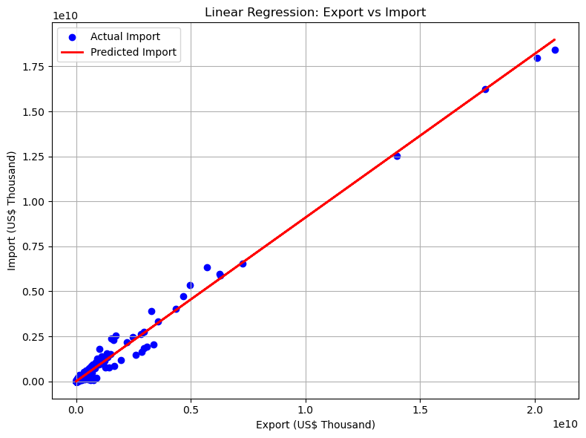
#Playing with Missing Data
# importing libraries
import pandas as pd
import numpy as np
# loading dataset
dataset = pd.read_csv(r"C:\Users\Prem Panchal\Downloads\34_years_world_export_import_dataset.csv")
dataset.head()
Partner Name Year Export (US$ Thousand) Import (US$ Thousand) \
0 Aruba 1988 3498.10 328.49
1 Afghanistan 1988 213030.40 54459.52
2 Angola 1988 375527.89 370702.76
3 Anguila 1988 366.98 4.00
4 Albania 1988 30103.56 47709.30
Export Product Share (%) Import Product Share (%) \
0 100.0 100
1 100.0 100
2 100.0 100
3 100.0 100
4 100.0 100
Revealed comparative advantage World Growth (%) Country Growth (%) \
0 NaN NaN NaN
1 NaN NaN NaN
2 NaN NaN NaN
3 NaN NaN NaN
4 NaN NaN NaN
AHS Simple Average (%) ... MFN Total Tariff Lines \
0 2.80 ... 1152.0
1 0.88 ... 4142.0
2 2.02 ... 5438.0
3 3.71 ... 322.0
4 1.84 ... 5684.0
MFN Dutiable Tariff Lines Share (%) MFN Duty Free Tariff Lines Share (%) \
0 63.54 22.74
1 69.41 15.64
2 76.00 16.27
3 66.15 22.05
4 66.87 19.19
MFN Specific Tariff Lines Share (%) MFN AVE Tariff Lines Share (%) \
0 70.32 31.61
1 72.45 40.51
2 41.55 24.80
3 78.79 36.36
4 57.93 48.52
MFN MaxRate (%) MFN MinRate (%) MFN SpecificDuty Imports (US$ Thousand) \
0 352.69 0.0 2186.00
1 2029.66 0.0 78436.91
2 451.15 0.0 727741.99
3 100.00 0.0 94.00
4 3000.00 0.0 37904.09
MFN Dutiable Imports (US$ Thousand) MFN Duty Free Imports (US$ Thousand)
0 3128.02 0.0
1 94191.50 0.0
2 921481.52 0.0
3 583.00 0.0
4 101195.95 0.0
[5 rows x 33 columns]
# missing values in the dataset
missing_values = dataset.isnull().sum()
missing_values
Partner Name 0
Year 0
Export (US$ Thousand) 0
Import (US$ Thousand) 0
Export Product Share (%) 20
Import Product Share (%) 0
Revealed comparative advantage 3384
World Growth (%) 3686
Country Growth (%) 3686
AHS Simple Average (%) 16
AHS Weighted Average (%) 16
AHS Total Tariff Lines 16
AHS Dutiable Tariff Lines Share (%) 16
AHS Duty Free Tariff Lines Share (%) 16
AHS Specific Tariff Lines Share (%) 16
AHS AVE Tariff Lines Share (%) 16
AHS MaxRate (%) 16
AHS MinRate (%) 16
AHS SpecificDuty Imports (US$ Thousand) 15
AHS Dutiable Imports (US$ Thousand) 15
AHS Duty Free Imports (US$ Thousand) 15
MFN Simple Average (%) 15
MFN Weighted Average (%) 15
MFN Total Tariff Lines 15
MFN Dutiable Tariff Lines Share (%) 15
MFN Duty Free Tariff Lines Share (%) 15
MFN Specific Tariff Lines Share (%) 16
MFN AVE Tariff Lines Share (%) 16
MFN MaxRate (%) 15
MFN MinRate (%) 15
MFN SpecificDuty Imports (US$ Thousand) 15
MFN Dutiable Imports (US$ Thousand) 15
MFN Duty Free Imports (US$ Thousand) 15
dtype: int64
missing_values[missing_values > 0]
Export Product Share (%) 20
Revealed comparative advantage 3384
World Growth (%) 3686
Country Growth (%) 3686
AHS Simple Average (%) 16
AHS Weighted Average (%) 16
AHS Total Tariff Lines 16
AHS Dutiable Tariff Lines Share (%) 16
AHS Duty Free Tariff Lines Share (%) 16
AHS Specific Tariff Lines Share (%) 16
AHS AVE Tariff Lines Share (%) 16
AHS MaxRate (%) 16
AHS MinRate (%) 16
AHS SpecificDuty Imports (US$ Thousand) 15
AHS Dutiable Imports (US$ Thousand) 15
AHS Duty Free Imports (US$ Thousand) 15
MFN Simple Average (%) 15
MFN Weighted Average (%) 15
MFN Total Tariff Lines 15
MFN Dutiable Tariff Lines Share (%) 15
MFN Duty Free Tariff Lines Share (%) 15
MFN Specific Tariff Lines Share (%) 16
MFN AVE Tariff Lines Share (%) 16
MFN MaxRate (%) 15
MFN MinRate (%) 15
MFN SpecificDuty Imports (US$ Thousand) 15
MFN Dutiable Imports (US$ Thousand) 15
MFN Duty Free Imports (US$ Thousand) 15
dtype: int64
dataset.shape
(8096, 33)
# total data in the dataset
total_dataset = np.product(dataset.shape)
total_dataset
267168
# total missing values
total_missing = missing_values.sum()
total_missing
11147
# total percentage of missing values
percent = (total_missing / total_dataset) * 100
percent
4.172281111510361
y = dataset['Export (US$ Thousand)']
y.head()
0 3498.10
1 213030.40
2 375527.89
3 366.98
4 30103.56
Name: Export (US$ Thousand), dtype: float64
drop = dataset.drop(['Export (US$ Thousand)'], axis = 1)
X = drop.select_dtypes(exclude = 'object')
X.head()
Year Import (US$ Thousand) Export Product Share (%) \
0 1988 328.49 100.0
1 1988 54459.52 100.0
2 1988 370702.76 100.0
3 1988 4.00 100.0
4 1988 47709.30 100.0
Import Product Share (%) Revealed comparative advantage World Growth (%) \
0 100 NaN NaN
1 100 NaN NaN
2 100 NaN NaN
3 100 NaN NaN
4 100 NaN NaN
Country Growth (%) AHS Simple Average (%) AHS Weighted Average (%) \
0 NaN 2.80 2.92
1 NaN 0.88 1.83
2 NaN 2.02 3.89
3 NaN 3.71 1.09
4 NaN 1.84 2.38
AHS Total Tariff Lines ... MFN Total Tariff Lines \
0 155.0 ... 1152.0
1 548.0 ... 4142.0
2 633.0 ... 5438.0
3 33.0 ... 322.0
4 744.0 ... 5684.0
MFN Dutiable Tariff Lines Share (%) MFN Duty Free Tariff Lines Share (%) \
0 63.54 22.74
1 69.41 15.64
2 76.00 16.27
3 66.15 22.05
4 66.87 19.19
MFN Specific Tariff Lines Share (%) MFN AVE Tariff Lines Share (%) \
0 70.32 31.61
1 72.45 40.51
2 41.55 24.80
3 78.79 36.36
4 57.93 48.52
MFN MaxRate (%) MFN MinRate (%) MFN SpecificDuty Imports (US$ Thousand) \
0 352.69 0.0 2186.00
1 2029.66 0.0 78436.91
2 451.15 0.0 727741.99
3 100.00 0.0 94.00
4 3000.00 0.0 37904.09
MFN Dutiable Imports (US$ Thousand) MFN Duty Free Imports (US$ Thousand)
0 3128.02 0.0
1 94191.50 0.0
2 921481.52 0.0
3 583.00 0.0
4 101195.95 0.0
[5 rows x 31 columns]
from sklearn.model_selection import train_test_split
X_train, X_test, y_train, y_test = train_test_split(X, y, train_size= 0.8, test_size= 0.2, random_state= 0)
from sklearn.metrics import mean_absolute_error
from sklearn.ensemble import RandomForestRegressor
def score_data(X_train, X_test, y_train, y_test):
model = RandomForestRegressor(n_estimators=100, random_state = 0)
model.fit(X_train, y_train)
pred = model.predict(X_test)
return mean_absolute_error(y_test, pred)
missing_with_columns = [col for col in X_train.columns if X_train[col].isnull().sum()]
drop_X_train = X_train.drop(missing_with_columns, axis = 1)
drop_X_test = X_test.drop(missing_with_columns, axis = 1)
print(score_data(drop_X_train, drop_X_test, y_train, y_test))
25236166.30298803
from sklearn.impute import SimpleImputer
impute = SimpleImputer()
imputed_X_train = pd.DataFrame(impute.fit_transform(X_train))
imputed_X_test = pd.DataFrame(impute.fit_transform(X_test))
imputed_X_train.columns = X_train.columns
imputed_X_test.columns = X_test.columns
print(score_data(imputed_X_train, imputed_X_test, y_train, y_test))
15968448.128519729
X_train_plus = X_train.copy()
X_test_plus = X_test.copy()
for col in missing_with_columns:
X_train_plus[col + "_was_missing"] = X_train_plus[col].isnull()
X_test_plus[col + "_was_missing"] = X_test_plus[col].isnull()
imputed_X_train_plus = pd.DataFrame(impute.fit_transform(X_train_plus))
imputed_X_test_plus = pd.DataFrame(impute.fit_transform(X_test_plus))
imputed_X_train_plus.columns = X_train_plus.columns
imputed_X_test_plus.columns = X_test_plus.columns
print(score_data(imputed_X_train_plus, imputed_X_test_plus, y_train, y_test))
15855818.724038702
#Bar Graph
import pandas as pd
import matplotlib.pyplot as plt
# Load the dataset
df = pd.read_csv(r"C:\Users\Prem Panchal\Downloads\34_years_world_export_import_dataset.csv")
# Get an overview of the data
print(df.head())
print(df.columns)
# Let's select the last two numeric columns for visualization (assuming they are exports and imports)
numeric_cols = df.select_dtypes(include=['int64', 'float64']).columns
if len(numeric_cols) >= 2:
exports_col = numeric_cols[-1] # Assuming the last column is exports
imports_col = numeric_cols[-2] # Assuming the second last column is imports
# Group by a specific column (if exists) or use the entire dataframe
if 'Country' in df.columns:
country_exports = df.groupby('Country')[exports_col].sum().sort_values(ascending=False).head(10)
country_imports = df.groupby('Country')[imports_col].sum().sort_values(ascending=False).head(10)
else:
country_exports = df[exports_col].sort_values(ascending=False).head(10)
country_imports = df[imports_col].sort_values(ascending=False).head(10)
# Create bar charts
fig, ax = plt.subplots(2, figsize=(10, 8))
if 'Country' in df.columns:
ax[0].bar(country_exports.index, country_exports.values)
ax[0].set_title(f'Top 10 Countries by Total {exports_col}')
ax[0].set_xlabel('Country')
ax[0].set_ylabel(exports_col)
ax[1].bar(country_imports.index, country_imports.values)
ax[1].set_title(f'Top 10 Countries by Total {imports_col}')
ax[1].set_xlabel('Country')
ax[1].set_ylabel(imports_col)
else:
ax[0].bar(range(len(country_exports)), country_exports.values)
ax[0].set_title(f'Top 10 Values by {exports_col}')
ax[0].set_xlabel('Index')
ax[0].set_ylabel(exports_col)
ax[1].bar(range(len(country_imports)), country_imports.values)
ax[1].set_title(f'Top 10 Values by {imports_col}')
ax[1].set_xlabel('Index')
ax[1].set_ylabel(imports_col)
plt.tight_layout()
plt.show()
else:
print("Not enough numeric columns for visualization.")
Partner Name Year Export (US$ Thousand) Import (US$ Thousand) \
0 Aruba 1988 3498.10 328.49
1 Afghanistan 1988 213030.40 54459.52
2 Angola 1988 375527.89 370702.76
3 Anguila 1988 366.98 4.00
4 Albania 1988 30103.56 47709.30
Export Product Share (%) Import Product Share (%) \
0 100.0 100
1 100.0 100
2 100.0 100
3 100.0 100
4 100.0 100
Revealed comparative advantage World Growth (%) Country Growth (%) \
0 NaN NaN NaN
1 NaN NaN NaN
2 NaN NaN NaN
3 NaN NaN NaN
4 NaN NaN NaN
AHS Simple Average (%) ... MFN Total Tariff Lines \
0 2.80 ... 1152.0
1 0.88 ... 4142.0
2 2.02 ... 5438.0
3 3.71 ... 322.0
4 1.84 ... 5684.0
MFN Dutiable Tariff Lines Share (%) MFN Duty Free Tariff Lines Share (%) \
0 63.54 22.74
1 69.41 15.64
2 76.00 16.27
3 66.15 22.05
4 66.87 19.19
MFN Specific Tariff Lines Share (%) MFN AVE Tariff Lines Share (%) \
0 70.32 31.61
1 72.45 40.51
2 41.55 24.80
3 78.79 36.36
4 57.93 48.52
MFN MaxRate (%) MFN MinRate (%) MFN SpecificDuty Imports (US$ Thousand) \
0 352.69 0.0 2186.00
1 2029.66 0.0 78436.91
2 451.15 0.0 727741.99
3 100.00 0.0 94.00
4 3000.00 0.0 37904.09
MFN Dutiable Imports (US$ Thousand) MFN Duty Free Imports (US$ Thousand)
0 3128.02 0.0
1 94191.50 0.0
2 921481.52 0.0
3 583.00 0.0
4 101195.95 0.0
[5 rows x 33 columns]
Index(['Partner Name', 'Year', 'Export (US$ Thousand)',
'Import (US$ Thousand)', 'Export Product Share (%)',
'Import Product Share (%)', 'Revealed comparative advantage',
'World Growth (%)', 'Country Growth (%)', 'AHS Simple Average (%)',
'AHS Weighted Average (%)', 'AHS Total Tariff Lines',
'AHS Dutiable Tariff Lines Share (%)',
'AHS Duty Free Tariff Lines Share (%)',
'AHS Specific Tariff Lines Share (%)', 'AHS AVE Tariff Lines Share (%)',
'AHS MaxRate (%)', 'AHS MinRate (%)',
'AHS SpecificDuty Imports (US$ Thousand)',
'AHS Dutiable Imports (US$ Thousand)',
'AHS Duty Free Imports (US$ Thousand)', 'MFN Simple Average (%)',
'MFN Weighted Average (%)', 'MFN Total Tariff Lines',
'MFN Dutiable Tariff Lines Share (%)',
'MFN Duty Free Tariff Lines Share (%)',
'MFN Specific Tariff Lines Share (%)', 'MFN AVE Tariff Lines Share (%)',
'MFN MaxRate (%)', 'MFN MinRate (%)',
'MFN SpecificDuty Imports (US$ Thousand)',
'MFN Dutiable Imports (US$ Thousand)',
'MFN Duty Free Imports (US$ Thousand)'],
dtype='object')
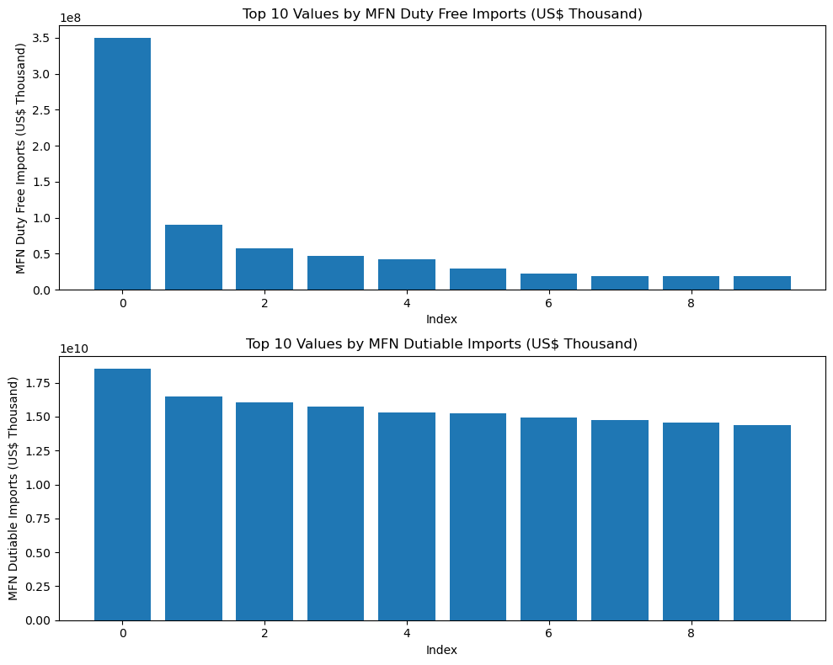
import pandas as pd
import matplotlib.pyplot as plt
import seaborn as sns
# Load the dataset
df = pd.read_csv(r"C:\Users\Prem Panchal\Downloads\34_years_world_export_import_dataset.csv")
# Select numeric columns
numeric_df = df.select_dtypes(include=['int64', 'float64'])
# Calculate correlation matrix
corr_matrix = numeric_df.corr()
# Create a heatmap
plt.figure(figsize=(10, 8))
sns.heatmap(corr_matrix, annot=True, cmap='coolwarm', square=True)
plt.title('Correlation Heatmap')
plt.show()
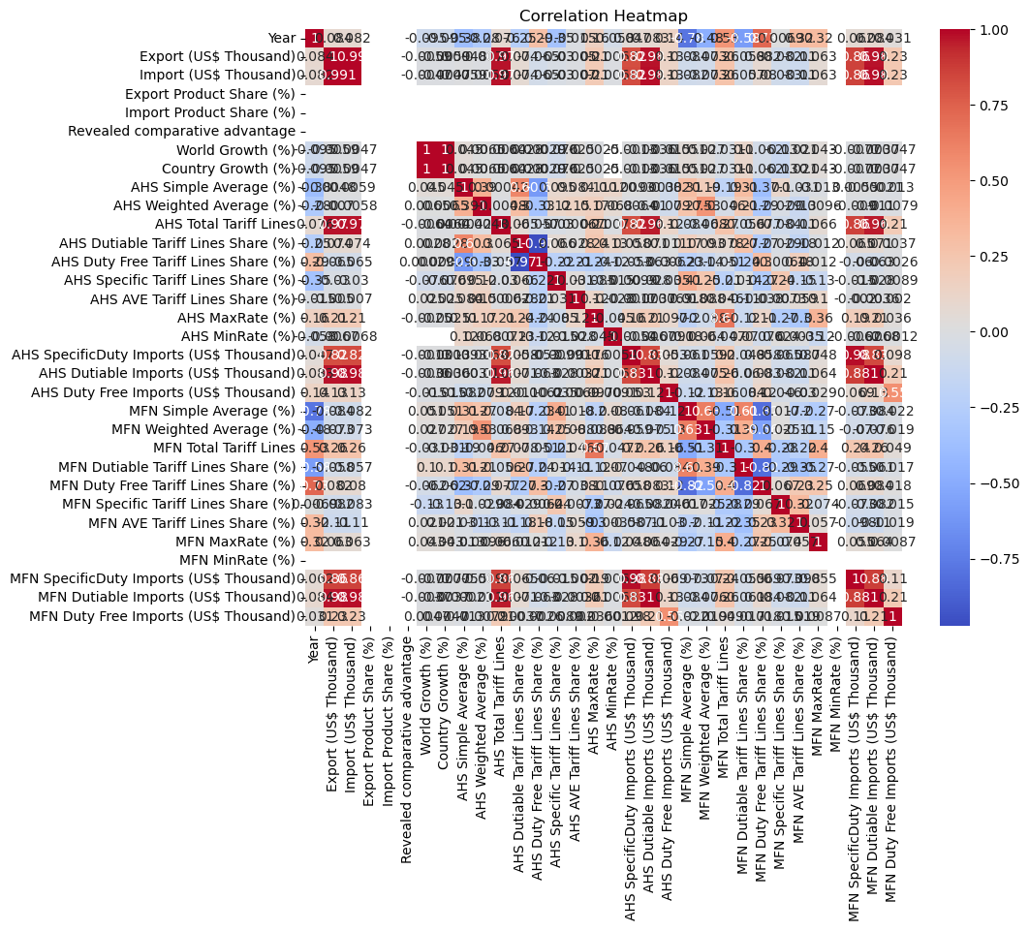
#Box Plot
import pandas as pd
import matplotlib.pyplot as plt
import seaborn as sns
# Load the dataset
df = pd.read_csv(r"C:\Users\Prem Panchal\Downloads\34_years_world_export_import_dataset.csv")
# Select numeric columns
numeric_df = df.select_dtypes(include=['int64', 'float64'])
# Create box plots
fig, ax = plt.subplots(figsize=(10, 6))
sns.boxplot(data=numeric_df)
plt.title('Box Plots of Numeric Columns')
plt.xticks(rotation=90)
plt.tight_layout()
plt.show()
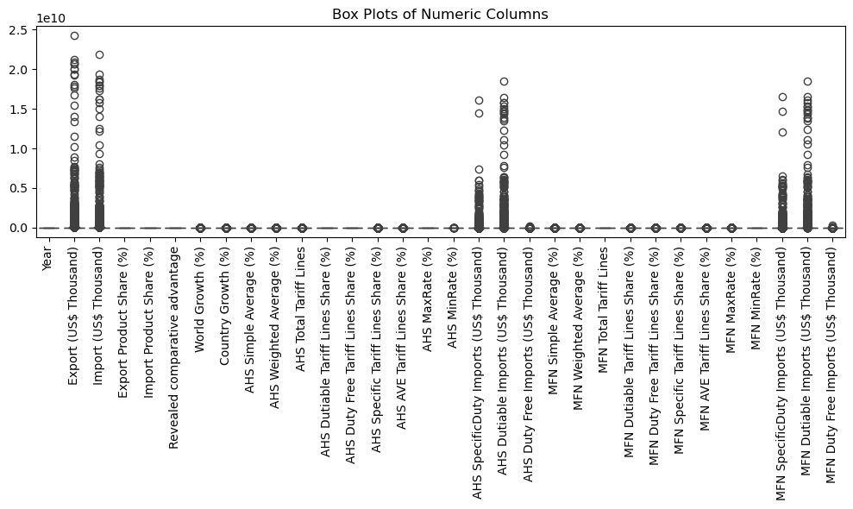
#Time series Analysis
import pandas as pd
import matplotlib.pyplot as plt
from statsmodels.tsa.seasonal import seasonal_decompose
from statsmodels.tsa.stattools import adfuller
# Load the dataset
df = pd.read_csv(r"C:\Users\Prem Panchal\Downloads\34_years_world_export_import_dataset.csv")
# Convert date column to datetime format (if it exists)
if 'Year' in df.columns:
df['Year'] = pd.to_datetime(df['Year'], format='%Y')
df.set_index('Year', inplace=True)
# Select a numeric column for analysis
numeric_col = df.select_dtypes(include=['int64', 'float64']).columns[0]
ts = df[numeric_col]
# Plot the time series
plt.figure(figsize=(10, 6))
plt.plot(ts)
plt.title(f'Time Series Plot of {numeric_col}')
plt.xlabel('Date')
plt.ylabel(numeric_col)
plt.show()
# Perform seasonal decomposition with a specified period
period = 5 # Adjust this value based on your data
decomposition = seasonal_decompose(ts, model='additive', period=period)
trend = decomposition.trend
seasonal = decomposition.seasonal
residual = decomposition.resid
plt.figure(figsize=(10, 8))
plt.subplot(411)
plt.plot(ts, label='Original')
plt.legend(loc='best')
plt.subplot(412)
plt.plot(trend, label='Trend')
plt.legend(loc='best')
plt.subplot(413)
plt.plot(seasonal,label='Seasonality')
plt.legend(loc='best')
plt.subplot(414)
plt.plot(residual, label='Residuals')
plt.legend(loc='best')
plt.tight_layout()
plt.show()
# Perform Augmented Dickey-Fuller test for stationarity
result = adfuller(ts)
print('ADF Statistic:', result[0])
print('p-value:', result[1])
else:
print("No date column found in the dataset.")
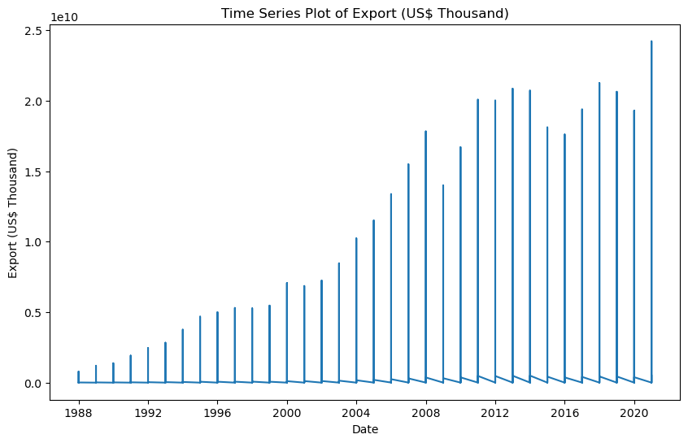
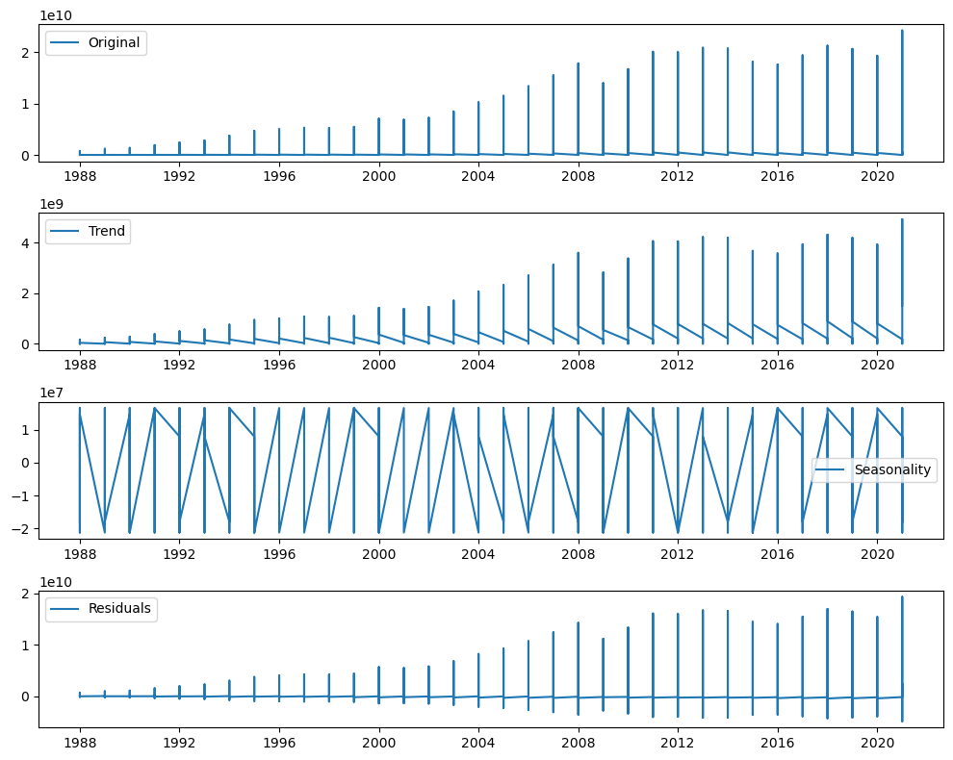
ADF Statistic: -13.057911428738935
p-value: 2.076297118730091e-24

